**OPTIMIZATION OF PLATE-FIN HEAT EXCHANGER USING Grey wolf optimization, GENETIC ALGORITHM AND PARTICLE SWARM OPTIMIZATION ALGORITHMS**

yousef hosny abdelazim hassan elsayed

A graduation exercise submitted to the Faculty of Engineering, University of Malaya in partial fulfilment of the requirement for the Degree of Bachelor in Mechanical Engineering

DEPARTMENT OF MECHANICAL ENGINEERING  
FACULTY OF ENGINEERING  
UNIVERSITY OF MALAYA

JUNE 2021

**DECLARATION BY THE CANDIDATE**

I, Yousef Hosny Elsayed, hereby declare that except where due acknowledgement has been made, the work presented in this thesis is my own, and has not been submitted previously in whole or in part, to qualify for other academic award.

The content of this graduation exercise is result of the work I have been carrying out since the official commencement date of the approved thesis project.



Date:18/6/2021 Signature:

Full Name: Yousef Hosny Elsayed

NRIC No: A18739918

Date: Supervisor’s Signature and Stamp:

**ABSTRAK**

Permintaan tenaga yang meningkat dengan ketara belakangan ini menjadikan keperluan peralatan cekap tenaga di loji proses dan industri suatu keperluan bagi menepati syarat-syarat yang ditetapkan oleh kerajaan. Penukar Haba Plat-Fin (PFHE) adalah salah satu penukar haba yang paling cekap tenaga dan terma berkesan kerana kepadatannya yang tinggi menjadikan ketumpatan kawasan permukaannya lebih tinggi daripada berbanding penukar haba tradisional. Walaubagaimanapun, masalah utama yang berkaitan dengannya adalah kos yang mahal disebabkan oleh kerumitan yang terlibat dalam proses pembuatannya. Dalam projek ini kita akan mengoptimumkan reka bentuk Penukar Haba Plat-Fin dengan objektif untuk meminimumkan jumlah kos tahunannya (TAC), namun untuk memastikan bahawa pengoptimuman TAC tidak mengakibatkan prestasi yang lebih rendah, batasan ditambahkan dalam fungsi objektif untuk memastikan bahawa penurunan tekanan, ciri aliran bendalir kerja dan berat PFHE mempunyai batas yang dapat diterima. Pengoptimuman PFHE akan dilakukan dengan menggunakan Algoritma Pengoptimuman Serigala Kelabu (GWO), Algoritma Genetik (GA) dan Algoritma Pengoptimuman Kawanan Partikel (PSO), hasil yang diperoleh akan dibandingkan antara satu sama lain dan dibandingkan dengan hasil yang diperoleh oleh penyelidikan lain yang menggunakan algoritma pengoptimuman yang berbeza dengan tujuan menilai algoritma berprestasi terbaik dalam mengoptimumkan sistem terma secara amnya dan khususnya PFHE.

ABSTRACT

Energy demand has increased substantially recently, the need of energy efficient equipment in process plants and industries has become a must to stay withing the emission boundaries set by the government. Plate Fin Heat Exchangers (PFHE) are one of the most energy efficient and thermally effective heat exchangers that’s due to their high compactness which makes their surface area density higher than traditional heat exchangers. However, a big issue associated with them is their high cost due to the complexity involved in the manufacturing process. In this project optimization has been conducted to the design of the Plate Fin Heat Exchanger with the objective of minimizing its total annual cost (TAC). However, to ensure that the optimization of the TAC does not come with the cost of lower performance, constraints are added in the objective function to ensure that the pressure drop, flow characteristics of the working fluids and the heat duty of the PFHE are within acceptable boundaries, Optimization of the PFHE will be done using Grey Wolf Optimization Algorithm (GWO), Genetic Algorithm (GA) and Particle Swarm Optimization Algorithm (PSO) , The results obtained from these algorithms will be compared with each other and compared with results obtained by other researches who used different optimization Algorithms with the aim of evaluating the best preforming algorithm in optimizing thermal systems generally and PFHE’s specifically.

**TABLE OF CONTENTS**

**ABSTRACT** iii

**LIST OF FIGURES** vii

**LIST OF TABLES** viii

**LIST OF SYMBOLS AND ABBREVIATIONS** ix

**CHAPTER 1: INTRODUCTION** 1

1.1 Introduction to Evolutionary Algorithms 1

1.1.1 Grey Wolf Optimization Algorithm 2

1.1.2 Genetic Algorithm 3

1.1.3 Particle Swarm Optimization Algorithm 5

1.2 Compact Heat Exchangers 6

1.2.1 Plate Fin Heat Exchangers 8

1.3 Problem Statement 9

1.4 Research Objectives 10

1.5 Scope of Research 11

**CHAPTER 2: LITERATURE REVIEW** 13

2.1 Plate Fin Heat Exchanger 13

2.1.1 Structure of Plate Fin Heat Exchangers 14

2.1.2 Types of Flows in Plate Fin Heat Exchangers 15

2.1.3 Types of Fins in Plate Fin Heat Exchangers 17

2.1.4 Thermal Model 19

2.2 Grey Wolf Optimization Algorithm 23

2.2.1 Encircling the Prey 25

2.2.2 Hunting the Prey 27

2.2.3 Applications of Grey Wolf Optimization 28

2.3 Genetic Algorithm 29

2.3.1 Selection 29

2.3.2 Cross-Over 30

2.3.3 Mutation 30

2.3.4 Applications of Genetic Algorithm 31

2.4 Particle Swarm Optimization 33

2.4.1 Particle Swarm Optimization Mathematical Model 33

2.4.2 Applications of Particle Swarm Optimization 35

2.5 Optimizations on Plate Fin Heat Exchangers 37

**CHAPTER 3: METHODOLOGY** 41

3.1 Objective Definition 41

3.2 Case Study 41

3.3 Objective Function and Constraints 43

3.4 Optimization Methods 46

3.4.1 Grey Wolf Optimizer Implementation 47

3.4.2 Genetic Algorithm Optimization Implementation 48

3.4.3 Particle Swarm Optimization Implementation 49

3.5 Optimization of GWO, GA and PSO algorithms. 50

**CHAPTER 4: RESULTS AND DISCUSSION** 51

4.1 Grey Wolf Optimization algorithm Best Solution, Properties and Performance 51

4.2 Genetic Algorithm Best Solution, Properties and Performance 52

4.3 Particle Swarm Optimization algorithm Best Solution, Properties and Performance 53

4.4 Discussion and Analysis 54

**CHAPTER 5: CONCLUSION** 57

**APPENDIX I: RESEARCH WORK SCHEDULE** 58

**REFERENCES** 59

LIST OF FIGURES

Figure 1.1: EA Flow chart 2

Figure 1.2: Example of a solution space 4

Figure 1.3: PFHE parting plate and fins 8

Figure 1.4: Popularity of Evolutionary Algorithms (2008 – 2018) 11

Figure 2.1: Structure of PFHE 14

Figure 2.2: Types of flows in PFHE 16

Figure 2.3: Detailed geometry of an offset strip fin 19

Figure 2.4: Schematic Diagram of crossflow plate-fin heat exchanger 20

Figure 2.5: Grey wolves pack domination hierarchy 23

Figure 2.6: Distribution of possible solutions 24

Figure 2.7: 2D simulation of the position of the Prey and the position of the wolves 25

Figure 2.8: Particle with position and velocity vector 33

Figure 2.9: Velocity update of particles 34

Figure 2.10: Position update of particles 35

Figure 3.1: GWO Flow Chart 47

Figure 3.2: GA Flow chart 48

Figure 3.3: PSO Flow Chart 49

Figure 4.1: GWO Best solution convergence graph 51

Figure 4.2: GA Best solution convergence graph 52

Figure 4.3: PSO Best solution convergence graph 53

LIST OF TABLES

Table 2.1: Candidates parameters before the cross-over 30

Table 2.2: Offspring parameters after the cross-over 30

Table 3.1: Preliminary design and total annual cost of the Plate Fin Heat Exchanger 41

Table 3.2: Operating conditions of the case study (input) 42

Table 3.3: Lower and upper bounds of the design parameters (output) 43

Table 3.4: Economic parameters of the PFHE 43

Table 4.4: Comparison between GWO, GA, PSO and ICA algorithms 54

LIST OF SYMBOLS AND ABBREVIATIONS

|  |  |  |  |  |
| --- | --- | --- | --- | --- |
|  | Heat Transfer area | J | Colburn factor | |
|  | Free flow area (Hot side) | G | Mass flux velocity | |
|  | Free flow area (Cold side) |  | Cost per unit area | |
|  | Heat Transfer area of the hot side |  | Mass flow rate | |
|  | Heat Transfer area of the cold side |  | Fin spacing | |
|  | Maximum heat capacity |  | Lance length of the fin | |
|  | Minimum heat capacity |  | Hydraulic diameter | |
|  | Specific heat |  | Pressure drops of hot fluid | |
|  | Heat capacity ratio |  | Pressure drops of cold fluid | |
|  | Fin height (Hot side) |  |  | |
|  | Fin height (Cold side) |  |  | |
|  | Hot side flow length |  |  | |
|  | Cold side flow length | *Greek Symbols* | |  |
|  | Hot side layers |  | Effectiveness | |
|  | Cold side layers |  | Electricity price | |
|  | Cognitive acceleration constant |  | Hours of operation | |
|  | Social acceleration constant |  | Compressor efficiency | |
|  | Fin frequency (Hot side) |  | Density of working fluid | |
|  | Fin frequency (Cold side) |  | Viscosity | |
|  | Fin thickness (Hot side) |  | Friction factor | |
|  | Fin thickness (Cold side) |  |  | |
|  | Velocity vector |  |  | |
|  | Position vector |  |  | |
|  | Inertia weight |  |  | |
| CHE | Compact Heat Exchanger |  |  | |
| EA | Evolutionary Algorithm |  |  | |
| GA | Genetic Algorithm |  |  | |
| GWO | Grey Wolf Optimization Algorithm |  |  | |
|  | Heat Transfer Coefficient |  |  | |
| NTU | Number of transfer units |  |  | |
| PCHE | Printed Circuit Heat Exchanger |  |  | |
| PFHE | Plate Fin Heat Exchanger |  |  | |
| PHE | Plate Heat Exchanger |  |  | |
| PSO | Particle Swarm Optimization |  |  | |
| TAC | Total Annual Cost |  |  | |
| TBHE | Tube Fin Heat Exchanger |  |  | |
|  | Heat of the fluid |  |  | |
|  | Overall Heat Transfer Coefficient |  |  | |
| Pr | Prandtl number |  |  | |

CHAPTER 1: INTRODUCTION

1.1 Introduction to Evolutionary Algorithms

Evolutionary computing is a group of algorithms that are inspired from nature and they are aimed to optimize complex problems subjected to constraints, which makes it common in fields like Engineering and Computer science. Evolutionary computing consists of different algorithms, named as Evolutionary Algorithms (EA)’s which work on the concept of survival of the fittest. It is inspired by the Darwinian theory of evolution.

Optimization is applicable in almost all fields; EA’s can be applied to everything from cells research to power plants. Their applications are only limited by the engineer’s imagination, for example, in engineering, EA’s are used to find optimal robot trajectories, they are also used to train fuzzy logic systems and neural networks. EA’s can be used in medical diagnoses as well, for example, after a biopsy, how can the doctor identify the cancerous cells? Which cell features are important ? Which cells are not important to identify it as a cancerous cell? An EA is capable of making these decisions. Evolutionary Algorithms should be considered whenever you are looking to solve a complex problem, if you are designing a wind turbine, heat exchanger, housing project, transportation system or even complicated electrical circuits where the designing problem is complex and subjected to constraints an EA is capable of solving these problems. The working mechanism of an Evolutionary Algorithm can be summarized in four steps as shown in Figure 1.1: Initialization, Selection, Operators and Termination, these steps each correspond, roughly to a particular facet or natural selection, the fittest population will survive and reproduce while the non-fit population will die off and they will not contribute to the gene pool of further generations, much like natural selection.

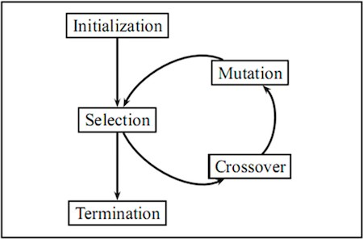

Figure 1.1: EA Flow chart

The following List contains the most common Evolutionary Algorithms

1. Ant colony optimization algorithm
2. Artificial immune systems algorithm
3. Differential evolution algorithm
4. Evolutionary programming
5. Genetic algorithm
6. Memetic algorithms
7. Neuroevolutionary
8. Particle swarm optimization

In this project, Grey Wolf Optimization (GWO), Genetic algorithm (GA) and Particle Swarm Optimization (PSO) algorithms will be used to optimize our design problem.

1.1.1 Grey Wolf Optimization Algorithm

Grey wolf optimization is a metaheuristic algorithm that’s inspired by the social hierarchy and the hunting techniques of Grey Wolves. It was invented by Mirjaliali Mohammed and Lewis in 2014.

A Grey wolf pack is divided into 4 hierarchical levels, the most dominant wolf is alpha, the 2nd most dominant wolf is beta, the 3rd most dominant wolf is delta, and finally the rest of the wolf pack is referred to as omega. The GWO Algorithm implements this social hierarchical mechanism in an optimization problem by dividing all the possible solutions in an iteration among the 4 hierarchical levels, where the 1st best solution is stored in the alpha wolf, the 2nd best solution is stored in the beta wolf, the 3rd best solution is stored in the delta wolf and the remaining solutions are stored in the omega wolves. In the next iteration, the omega wolves pack will update their position according to the positions of alpha, beta and omega (Mirjalili *et al.,* 2014).

The original release of the GWO algorithm was designed to solve problems that does not have constraints and has only one objective, thus it can be considered as a single-objective-no-constraint algorithm. However in real world applications, constraints are always present and need to be considered, that’s why GWO algorithm went through a series of modifications and since then a lot of variants were released (Kohli *et al.,* 2017).

In this project, The (Chaotic GWO) which is a version of the original GWO that is capable of handling constraints will be implemented on the design optimization problem.

1.1.2 Genetic Algorithm

Genetic Algorithms (GA)’s work on the concept of evolution developed by Darwin (Survival of the fittest). It was invented by Jhon Holland in 1975. Genetic Algorithms handles a set of population that contains possible solutions, every solution is represented by a chromosome in a parent, reproduction operators are programmed and applied to the parents to cause mutations and reproduce off springs with better solutions.

Selection operators compare the solutions of every individual in the population using a fitness function. Every chromosome contains a value that corresponds to the fitness function, this way the solution is evaluated to identify how good the parent is, the optimal solution is the solution that maximizes/minimizes the fitness function.

When the fitness function and the reproduction operators are programmed properly, the Genetic Algorithms start working by generating a random initial set of population that represents solutions in the solution space, these solutions are stored inside the chromosomes, Then the GA loops over a process to make the set of population evolve and contain better solutions, the process can be summarized by the following steps:

1. *Selection:* The first step is to select parents for reproduction, the selection process is random with a probability depending on the relative fitness of the individuals so that best ones are often chosen for reproduction than poor ones.
2. *Reproduction:* In this step the selected parents are combined together to produce offspring that contain better chromosomes (solutions)
3. *Evaluation:* In this step the chromosomes of the offspring is evaluated
4. *Replacement:* Once it’s proven that the offspring contains better chromosomes than the parents, the parents are removed, and the offspring replaces them to become the new parents.

This process occurs in a solution space that is defined by an objective function and a set of constraints. The solution space as shown in Figure 1.2 is the space which contains all feasible solutions (the set of solutions that contain the optimal solution among them). Every point in the solution space represents a possible solution, therefore every parent will contain a fitness value (best solution so far) that will be stored inside him as a chromosome



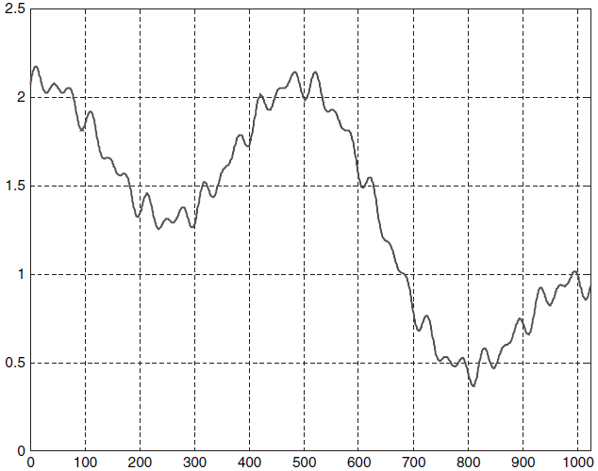

Figure 1.2: Example of a solution space

The algorithms stop running when the population converges to the optimal solution.

1.1.3 Particle Swarm Optimization Algorithm

Particle Swarm Optimization (PSO) is a population-based optimization method that was developed by Dr. Ebrahart and Dr. Kennedy in 1995, It’s inspired by the social attitude of the flow of birds.

It starts by initializing a swarm consisting of particles that searches for optimal solutions, the birds are resembled by the term particles in PSO, these particles fly in the solution space by following the path of the fittest particles in the swarm. In the solution space, particles save their best solutions obtained so far in a value named pBest (Personal Best). Another optimal solution that is saved among all of the swarm is the global best solution, it’s the best solution obtained by any particle in the swarm so far and it’s saved in a value named gBest (Global Best) (Kennedy *et al.,* 1995).

In Particle Swarm Optimization (PSO) each particle is interacting with the rest of the swarm by updating its velocity continuously to achieve a new personal best (pBest) and globally best (gBest) positions, once new pBest or gBest positions are obtained the position memory gets updated and this process stays on loop until the swarm converges towards the optimal solution. PSO was applied successfully to many research areas like power systems and control, job scheduling, mobile networking, image processing and much more. It is also proven that PSO find better solutions faster than other optimization algorithms, another feature of PSO that makes it attractive is that it does not have many parameters to adjust (Deepa *et al.,* 2008).

1.2 Compact Heat Exchangers

The importance of compact heat exchangers (CHE’s) was realized in the fields of aerospace, automotive, electricity generation power plants and other industries in the past 50 or more years, this is due to several factors, for example the need for high performance yet low-cost heat exchangers and the need of using air or any other gas as an exchanger fluid. For the past two decades, and with the increase of global energy demand, there was a growing motive for using CHE’s and that is because it is considered a low energy consumption heat exchanger compared to non-compact heat exchangers, which results in reduced capital cost in process plants and other industries, in addition CHE’s offers lower floor space and a significant decrease in the fluid inventory and that is due to its high compactness (Hesselgreaves *et al.,* 2001).

The ratio of heat transfer area to the volume of a heat exchanger is used to measure its compactness, when a heat exchanger surface area density exceeds 700 it’s considered a compact heat exchanger (CHE) regardless of its structure and type. For example, car radiators have a surface area density of 1000 and glass ceramic heat exchangers for gas turbines where the surface area density is about 6600 are considered compact heat exchanger (CHE). Human lungs, which have a surface area density of 20000 are also an example of a CHE. However, shell and tube heat exchangers are not considered CHE since their surface area density ranges from 70 to 500 (Zohouri *et al.,* 2017).

The advantages of CHE’s are (Hesselgreaves *et al.,* 2001):

1. Improved thermal effectiveness
2. Low temperature differences between the exchanging fluids
3. Small in size
4. Usage of multiple working fluids
5. Energy Saving
6. Reduction in fluid inventory volume
7. Safety and reliability

These advantages make CHE’s economically and thermodynamically better than non-compact heat exchangers as it offers better energy utilization and heat transfer effectiveness (Zohouri *et al.,* 2017).

The most common types of compact heat exchangers are:

1. Plate and Frame Heat Exchangers (PHE)
2. Plate-Fin Heat Exchangers (PFHE)
3. Tube-Fin Heat Exchangers (TBHE)
4. Printed Circuit Heat Exchanger (PCHE)

When heat exchangers are used in cars, airplanes, ships, aerospace vehicles, refrigerators and air conditioners, lower size and weight become desirable and important, high compactness achieves this. To increase the effectiveness and compactness of CHE’s fins are used, thus, producing the Plate Fin Heat Exchangers (Zohouri *et al.,* 2017).

1.2.1 Plate Fin Heat Exchangers

Plate Fin Heat Exchangers (PFHE) is a type of compact heat exchangers where it is possible to improve the heat transfer area through extended metal interface between the working fluids and this extended metal is called “Fins”. PFHE’s offer excellent performance and efficiency in the heat transfer operation due to its high compactness, low weight, however it’s considered relatively expensive due to the details and complexity involved in their manufacturing process. PFHE’s consist of a set of flat plates and fins that are brazed together. The heat is transferred between working fluids when they are moving in the paths that are caused by the fins (Hesselgreaves *et al.,* 2001).

Fins do not only form extended metal interface between the working fluids, but they also function as a support to the structure of the heat exchanger by adding strength to the internal components of the PFHE against the pressure caused by the flow of the working fluids. Figure 1.3 shows an exploded view of the structure of 2 flat plates combined with a fin, such layers are added together to form the PFHE (Zohouri *et al.,* 2017).

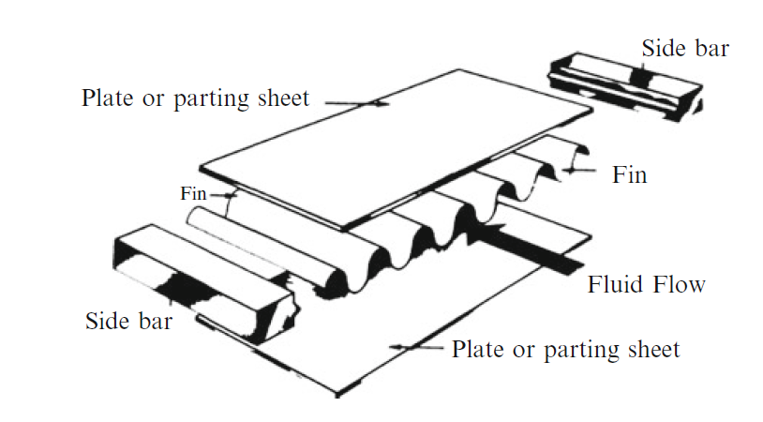

Figure 1.3: PFHE parting plate and fins

1.3 Problem Statement

Traditional mathematical techniques for obtaining the maximum and minimum values of a function have been applied to designing problems for quite a while. Despite the fact that these strategies may perform well in a lot of practical applications, however these techniques can lose their functionality when trying to optimize complicated design problems. In real world problems, there are a lot of design parameters considered and they have a complex influence on the objective function especially when they are bounded with constraints, the objective function can have a local maximum and minimum while the designer might be interested in the global maximum and minimum, such optimization problems cannot be solved by traditional mathematical techniques such as gradient method and linear programming, In such situations, Evolutionary algorithms come in handy as they have the ability to find the global minimum and maximum with good accuracy and computation time.

Thermal systems are complicated, and the designing procedure can be very complex due to the substantial number of parameters and constraints involved, in order to optimize a thermal system, EA rise as an attractive method to solve the optimization problem. Plate Fin Heat Exchangers (PFHE)’s are compact heat exchangers that are considered attractive due to their effectiveness, heat transfer efficiency, energy savings, size and weight. However, there is a limitation associated with them and that is their cost is very high due to the details and complexity involved in the manufacturing process.

To solve this problem, the design of the PFHE will be optimized to minimize its capital cost and operating cost, this is achieved through accurate thermal modeling, development of the objective function that describes the correlation between the capital cost, operating costs and constraints, and finally the application of GWO, GA and PSO algorithms to the objective function.

1.4 Research Objectives

1. To study the thermodynamic and economic model of Plate Fin Heat Exchangers (PFHE)’s.
2. Optimize the design of an offset strip cross flow Plate Fin Heat Exchanger with the objective of minimizing its total annual cost (TAC).
3. Develop the concepts of Grey Wolf Optimization (GWO), Genetic Algorithm (GA) and Particle Swarm Optimization (PSO) in the form of MATLAB code.
4. Identify the most efficient Evolutionary Algorithm in optimizing Plate Fin Heat Exchangers.

1.5 Scope of Research

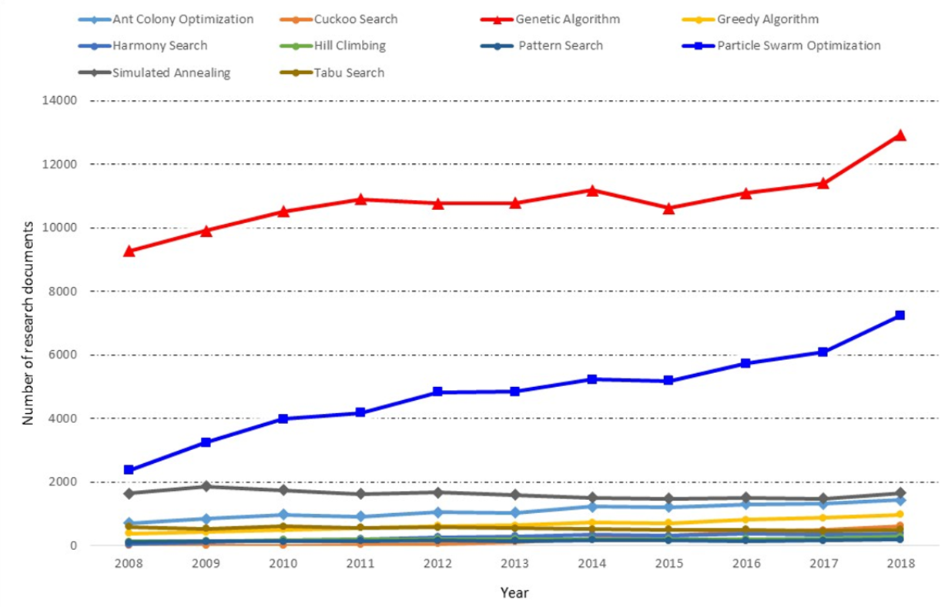There is a substantial number of Evolutionary algorithms, the most common ones are Genetic Algorithms, Ant colony optimization algorithm, Cultural algorithms, Differential evolution algorithm, Simulated annealing algorithm, Genetic Algorithm, Biogeography Algorithm, Harmony Elements Algorithms and Particle Swarm Optimization Algorithm. In this project the 2 most commonly used algorithms (GA and PSO) according to Scopus database as shown in Figure.1.4 and (GWO) algorithm will be used to optimize the design of the thermal system (Plate Fin Heat Exchanger).

Figure 1.4: Popularity of Evolutionary Algorithms (2008 – 2018)

However, there are a lot of types of Plate Fin Heat Exchangers (PFHE)’s depending on the application, PFHE’s are classified according to their fin, these include plain fins, serrated fins, porous fins, corrugated fins, venetian-blind fins, strip type fins and pin shaped fins, PFHE’s are also classified according to the flow of the working fluids, these include parallel flow, counter flow and cross pass flow. In this project the PFHE that is going to be optimized consist of offset strip fins and the flow arrangement is a crossflow, therefore it can be named an offset strip cross flow plate fin heat exchanger.

**1.6 Research Gap**

Optimization of Plate Fin Heat exchangers was never investigated and solved using Grey wolf optimization (GWO) algorithm. The main novelty of this project is the implementation of GWO algorithm to optimize the design of a Plate Fin Heat Exchanger with the objective of minimizing its total annual cost. Comparison between the results and computation time of GWO, GA and PSO algorithms is conducted in this project to evaluate the best performing algorithms in optimizing thermal systems generally and Plate Fin Heat Exchangers specifically.

CHAPTER 2: LITERATURE REVIEW

2.1 Plate Fin Heat Exchanger

Flamant (2011) highlights the most important characteristics of PFHE's like having large heat transfer surface area per unit volume (because fins are employed on both sides), high thermal conductivity due to a small thickness of the plate, and high effectiveness (because fins interrupt boundary layer growth). And states that due to these characteristics there is reduction of space requirement and weight which gives PFHE's an economic advantage over other non-compact heat exchangers, these features make PFHE's optimal heat exchangers in applications like Natural gas liquefaction, Cryogenic air separation, Ammonia production, Offshore processing, Nuclear engineering, Syngas production and Aircraft cooling of bleed air and cabin air. However, this greater thermal performance of the PFHE is at the expense of higher pressure drop. Therefore, the optimum design of PFHE always required the trade-off between the thermal and hydraulic performance of the heat exchanger within the given set of constraints. Generally, the objectives involved in the design optimization of PFHE are thermodynamics (i.e., maximum effectiveness, minimum entropy generation rate, minimum pressure drop, etc.), and economics (i.e., minimum cost, minimum weight, etc.)

2.1.1 Structure of Plate Fin Heat Exchangers

Hesselgreaves (2001) showcased the structure of the PFHE as set of plates combined together as shown in Figure 2.1, they consist of fins, parting plate and a sealing to stop leakages of working fluids from occurring. The fins and the sealings are placed between 2 parting plates creating inter layers called passages, these inter-layers are combined together through brazing to form the whole body of the PFHE.

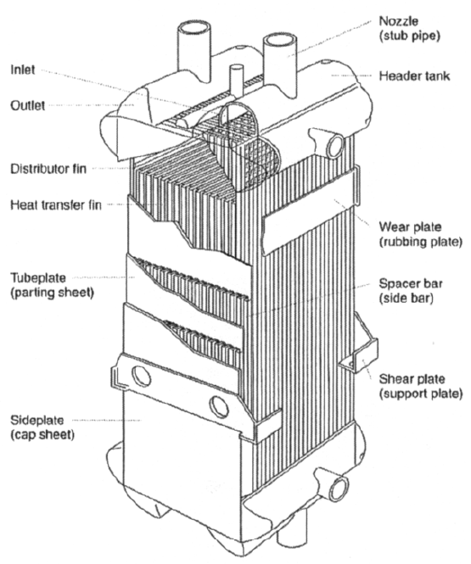

Figure 2.1: Structure of PFHE

In general, there is 1 or 2 layers called side plates that are placed on the sides of the PFHE body to stop the working fluids from flowing through the sides of the PFHE, then a flow guidance and shell cover are placed on the fluid inlets and outlets of the PFHE body. This way a complete PFHE is formed.

The materials used in the construction of PFHE’s include stainless steel, nickel, pure aluminum, titanium and copper. However, in this project the case study PFHE is made of Aluminum with a density of 2700 .

2.1.2 Types of Flows in Plate Fin Heat Exchangers

Hesselgreaves (2001) differentiated Compact heat exchanger according to the type of fluid flow, there are three primary types of fluid flows in heat exchangers as shown in Figure 2.2.

1. *Parallel flow:* In this type of heat exchangers, the exchanging fluids enter the heat exchangers from the same side, and they move parallel to each other side to side
2. *Counter flow:* In this type of heat exchangers, the exchanging fluids enter the heat exchanger from opposite sides, in a traditional heat exchanger (shell and tube) this type of flow is the most effective in the heat transfer process as it can transfer most of the heat to the heat medium per unit mass due to the fact that the difference in temperature along any unit length is higher
3. *Cross flow:* In this type of heat exchangers, the exchanging fluids move perpendicular to each other.

In the PFHE design process, the type of flow is defined, and it’s based on the application and the working fluids used in the heat transfer process. In this project the case study PFHE is a single-pass cross flow PFHE.

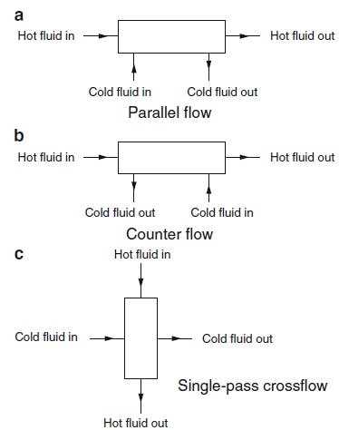

Figure 2.2: Types of flows in PFHE

2.1.3 Types of Fins in Plate Fin Heat Exchangers

Zohuri (2017) states that Fins are used to increase the heat transfer area and to improve the efficiency and compactness of the heat exchanger, Fins also adds strength to the structure of the PFHE, Zohuri also identifies the three main types of fins as:

1. *Plain Type Fin:* The distinctive features of plain type fins are that they offer a linear passage for the working fluids and increase the heat transfer area, however they have little to no impact in improving fluid turbulence. The characteristics of heat transfer and dynamics of the working fluids are similar to those of the working fluids in spherical tube heat exchangers, the long linear passage has good impact on the heat transfer between the fluids. In comparison with other fin types, the heat transfer coefficient and resistance are smaller.
2. *Serrated Type Fin:* The distinctive feature of this fin type is that it has small grooves along the length of the fin plate which forms a serrated shape passage. Serrated fins are very effective in fixing fluid turbulence. Therefore, serrated fins are considered one of the most effective fin types, with the same pressure drop, the heat transfer coefficient is high by 30% than a flat fin, but its resistance is bigger. Serrated fins are used as passages for gases and oils as they offer small temperature differences between the working fluids and can work with highly viscous fluids.
3. *Strip Type Fin:* This fin type is shaped through cutting the plain fin into short and discontinuous strips, these strips are then arranged in an unorganized way and there is a constant distance between them, the lengths of the fin along the direction of the flow are short and discontinuous, which makes the heat boundary layer on the fin break apart without anytime to regrow, thus the heat transfer performance of this fin type is considered very good.

The choice of the fin types is dependent on the application and the working fluids, it’s normally predetermined in the PFHE designing phase, however in this project the case study PFHE consists of an offset strip type fin.

This literature review examines the Thermal model of the PFHE, reviews optimizations that researchers have done previously on PFHE's and concludes that optimizing PFHE's through EA's is applicable on wide variety of objective functions such as minimizing cost, minimizing pressure drop, maximizing heat transfer area, maximizing effectiveness and minimizing number of entropy generation units.

2.1.4 Thermal Model

Sanaye and Hajabdollahi (2010), Rao and Patel (2013), Patel and Savsani (2014), and Raja (2017a, b) examined the thermal model of an offset crossflow plate fin heat exchangers and developed an effective thermal model that is presented here.

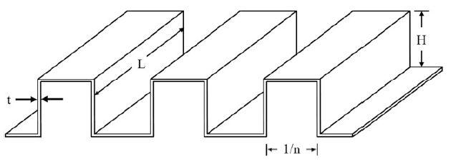

Figure 2.3: Detailed geometry of an offset strip fin

Incropera and DeWitt (1998) gave us the effectiveness correlation as the following:

(2.1)

Where the heat capacity ratio is given as

(2.2)

Where and are the minimum and maximum heat capacity fluids, respectively.

The heat of the fluid is given by

(2.3)

Where is the specific heat of the fluid.

The number of transfer units (NTU) is given by the following equation:

(2.4)

Where is the convective heat transfer coefficient, is the overall heat transfer coefficient, and is the heat transfer surface area.

Heat transfer areas of the hot and cold sides of the heat exchanger are obtained by

(2.5)

(2.6)

where and indicate cold-side and hot-side flow length as shown if Figure 2.4, and indicate the number of hot-side and cold-side layer, and indicate fin height on the hot side and cold side, and indicate fin thickness on the hot side and cold side, and and indicate fin frequency on the hot side and cold side, respectively.

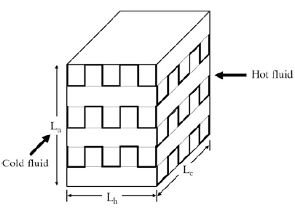

Figure 2.4: Schematic Diagram of crossflow plate-fin heat exchanger

Based on the hot side and cold side, the total heat transfer area of the heat exchanger is formulated as

(2.7)

The free flow area () for the hot side and cold side of the plate-fin heat exchanger geometry is given by

(2.8)

(2.9)

The heat transfer coefficient of the plate-fin heat exchanger is given by

(2.10)

where is the Colburn factor, is the Prandtl number, and is the mass flux velocity and are obtained using the following equations:

(2.11)

(2.12)

where μ and k are the viscosity and thermal conductivity of the fluids, respectively.

Manglik and Bergles (1995) gave us the correlation that from it the Colburn factor that is required to calculate the heat transfer coefficient is obtained

(2.13)

where is the Reynolds number; α, δ, and γ are dimensionless parameters and are given by:

(2.14)

(2.15)

(2.16)

(2.17)

(2.18)

where is the fin spacing, is the lance length of the fin, and is the hydraulic diameter and are calculated by the below equation.

(2.19)

Shah and Sekulic (2003) gave us the correlation needed to obtain the pressure drop of both the fluid streams of the plate-fin heat exchanger as the following:

(2.20)

(2.21)

where is the friction factor and is obtained by the following equation:

(2.22)

This thermal model of the Plate-Fin heat exchanger will be used to optimize the total cost of the PFHE.

2.2 Grey Wolf Optimization Algorithm

The Grey Wolf Optimization (GWO) algorithm was invented by Mirjilli and Lewis in 2014. The algorithm simulates the social behavior of grey wolves in the nature. A Grey wolf pack is divided into 4 hierarchical levels based on the domination level of an individual, the most dominant wolf is called alpha (**α**), the second most dominant is called beta (**β**), the third most dominant is called delta (**δ**) and the rest of the pack is called omega (**ω**) as shown in Figure 2.5.

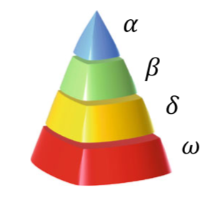

Figure 2.5: Grey wolves pack domination hierarchy

GWO Algorithm implements this domination hierarchy mechanism by distributing all possible solutions for an optimization problem among the 4 hierarchical level, this mechanism is shown in Figure 2.6, where there are 6 possible solutions for an optimization problem, the best solution is stored in α, the 2nd best solution is stored in β, the 3rd best solution is stored in δ, and the remaining 3 solutions are stored in ω. The social hierarchy is updated in every iteration before the solutions are changed, following that, the solutions are updated using two mechanisms, Encircling the prey mechanism and Hunting the prey mechanism.

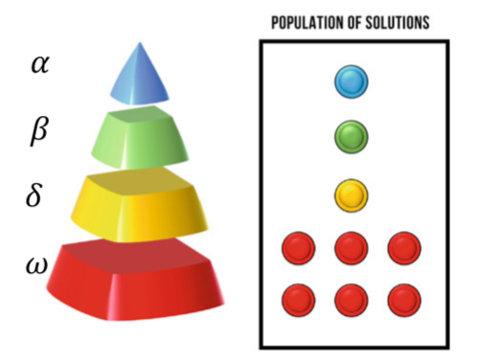

Figure 2.6: Distribution of possible solutions

2.2.1 Encircling the Prey

Regularly, grey wolves hunt in packs, this means they have a collaboration mechanism that allows them to successfully pin down preys. Grey wolves packs chase the prey at first with the objective of encircling it, following that they start changing their positions to come close to the prey and successfully hunt it, the computational simulation of this process is shown in Figure 2.7.

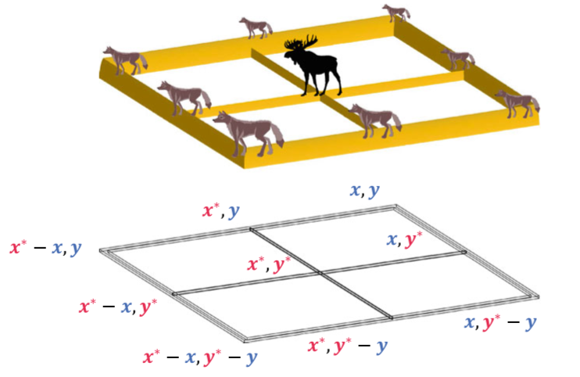

Figure 2.7: 2D simulation of the position of the Prey and the position of the wolves

Figure 2.7 shows the possible positions of grey wolves (x , y) relative to the prey position (x* , y*). This has been mathematically modeled using equation 2.23

(2.23)

Where is the next location of the wolf, is current location, is a coefficient and is the distance that depends on the location of the prey and is calculated as follows:

(2.24)

When merging both equations the resultant equation is:

(2.25)

Using equation 2.25, a solution can transform to another solution, since X is a vector, we can add an unlimited number of dimensions. The random operators in the above equation, and plays an important role in the algorithm, without these random operators grey wolves move to a constant number of positions around the prey (1 position for a 1D problem, 7 for a 2D problem and 25 for 3D problems). The equations that describe the random operators are as following:

(2.26)

(2.27)

Where is a variable that ranges from 0 till 2 and decreases in a linear manner during optimization. and range from 0 till 1 and they are randomly generated during optimization, the following formula 2.28 updates the variable during optimization.

(2.28)

Where shows the current iteration and is the maximum number of iterations.

2.2.2 Hunting the Prey

Equations 2.23 till 2.28 describe the mechanism of wolves relocating to positions around the prey. However this is not enough to represent the social intelligence of grey wolves, to simulate the prey, it is assumed that the best solution obtained so far (**α**) is the position of the prey since in real world application the position of the best solution is unknown.

Using the equations of encircling and defining the position of the prey, the positions of the wolves in the wolf pack can be updated using the following formulas

(2.29)

Where and and are calculated using the following equations

(2.30)

(2.31)

(2.32)

, and are calculated using the following equations

(2.33)

(2.34)

(2.35)

2.2.3 Applications of Grey Wolf Optimization

Grey wolf optimization (GWO) algorithm has been cited almost 5600+ as of May 2021 according to google scholar metrics times since it was first introduced in 2014. It has been used to solve real world problems. Tarek, Ebied, Hassanien and Tolba (2021) used GWO to segment and classify blood cells which enabled them to detect early blood diseases. Altan, Karasu and Zio (2021) were able to develop a hybrid model consisting of long short-term memory neural network, grey wolf optimizer and decomposition methods that is capable of accurately forecasting wind speed for efficient exploitation of wind power. Gupta and Saxena (2016) used GWO to find the parameters of primary governor loop for successful automatic generation control of two area’ interconnected power system, the results obtained by the GWO algorithm was compared with results of Particle Swarm Optimization (PSO) algorithm, Genetic Algorithm (GA) and Gravitation Search Algorithm (GSA), Gupta and Saxena (2016) stated that GWO outperformed all three algorithms. Lal, Barisal, Tripathy (2016) optimized an interconnected hydro-thermal power system for automatic generation control (AGC) using GWO. Das (2015) maximized the performance of a PID controller used in DC motor speed control using GWO.

This shows the wide variety of real world applications from disease detection to wind speed forecasting and PID controller optimization where GWO was implemented and successfully solved problems in these fields.

2.3 Genetic Algorithm

Holland (1975) Invented Genetic Algorithms (GA) in his book “Adaptation in Natural and Artificial Systems”, it’s considered the most used algorithm in solving optimization problems.

In GA, the input parameters of the optimization problem are encoded in a finite length solution strings, even though most of optimization algorithms are directly interfacing with the input parameters, GA’s usually interfaces with the population and candidates. When an initial population is randomly generated, genetic operators in the GA starts creating optimum solutions based on the solutions found in the initiated population. The genetic operators in GA are Selection, Cross-over and Mutation (Savsani *et al.,* 2012).

2.3.1 Selection

During the selection process, the fittest candidates in the initiated population are qualified to a mating pool to generate the new population (offspring). There most common selection operator is the Roulette wheel operator where the probability of the candidate to be qualified is determined by Equation 2.23, if his fitness value is close to the fittest candidate, he will have more entries in the roulette wheel, therefore the chances of him being qualified becomes high, After the selection procedure have occurred, cross-over and mutation are applied to the candidates.

(2.36)

2.3.2 Cross-Over

The cross-over operator main function is to recombine the design parameters that the qualified candidates are holding, when 2 or more candidates are chosen by the selection operator a one point is chosen at random to cut through the design parameters as shown in Table 2.1, and the parameters before the one-point cut are swapped to form new offspring as shown in Table 2.2

Table 2.1: Candidates parameters before the cross-over

|  |  |  |  |  |  |  |
| --- | --- | --- | --- | --- | --- | --- |
|  | Parameter 1 | Parameter 2 | Parameter 3 |  | Parameter 4 | Parameter 5 |
| Candidate 1 | 3 | 4 | 5 |  | 1 | 0 |
| Candidate 2 | 2 | 9 | 2 |  | 2 | 1 |

Table 2.2: Offspring parameters after the cross-over

|  |  |  |  |  |  |  |
| --- | --- | --- | --- | --- | --- | --- |
|  | Parameter 1 | Parameter 2 | Parameter 3 |  | Parameter 4 | Parameter 5 |
| Offspring 1 | 2 | 9 | 2 |  | 1 | 0 |
| Offspring 2 | 3 | 4 | 5 |  | 2 | 1 |

2.3.3 Mutation

Mutation usually alters some parameters of the candidates to form confounded solutions, unlike cross over operator which operates on 2 candidates, Mutation operates only on 1 candidate, the most common mutation operator is the bitwise operator, where every parameter that the candidate is holding is complemented with a mutation probability (Savsani *et al.,* 2012).

2.3.4 Applications of Genetic Algorithm

Sivanandam and Deepa (2008) highlight the applications of GA’s in the fields of engineering and operation management like Control of gas pipeline, Manufacturing scheduling and control, signal processing and the design of semiconductors, design of aircrafts, design of communication networks, sequence scheduling, routing and facilities layouts and the list goes on, however there has been a limitation when using GA’s to solve problems, and that is constraint handling. The most common and typical method that was previously used was using a penalty function by continuously testing different penalty numbers in your algorithm to find the most suitable number that will give you an optimal result, However, Deb (2000) proposed a constraint handling method that is applied to Genetic Algorithm where there is a tournament selection operator that will compare two solutions at the same time under certain criteria, the criteria is as following, any feasible solution is to be qualified if it’s compared by any infeasible solution, If two feasible solutions are compared then the solution with the better fitness value is qualified, if two infeasible solutions are compared then the solution that have less constraint violation is qualified. This method has been proven to be effective and efficient in handling constraints thus decreasing GA’s computation time and increasing GA’s accuracy in solving constraint problems.

GA’s has been used to optimize a substantial number of problems. A recent application in the Electrical field was by Boztas, Aydogmus, Caner and Guldemir (2019) where they optimized a low voltage synchronous reluctance motor’s barrier so that a minimum torque ripples and maximum average torque is achieved.

In the safety field Lin, Jiang, Hu, Zhou and Li (2019) optimized the layout model of a smart camera terminal that’s used for video surveillance, where they developed a model of the camera monitoring range and their objective was to minimize the average monitoring distance while considering constraints like site selection and cost, they used GA to solve this optimization problem and to find the optimal layout of the camera’s.

In the dynamics field Khan, Horoub, Safiq, Ali and Bhatti (2019) optimized a passive vehicle suspension system where the objective was to minimize the settling time and the optimization algorithm that was used to solve this problem was GA and Just recently, Salkuti (2020) used GA to optimize combined economic emission displace for power systems with thermal and wind energy generating equipment.

These wide variety of real-world applications strengthens the claim that GA’s are efficient and effective in solving optimization problems, which is one of the main reasons GA is used in optimizing the Plate Fin Heat Exchanger.

2.4 Particle Swarm Optimization

Kennedy and Eberhard (1995) were the first to introduce Particle Swarm Optimization (PSO) and it’s considered one of the most used and accurate algorithms in solving optimization problems.

2.4.1 Particle Swarm Optimization Mathematical Model

In Particle Swarm Optimization (PSO) every particle is accelerating towards it’s knows best position pbest, and the global best position gbest. Considering a swarm of particles flying through a parameter space and searching for the optimal parameter. Every particle in the swarm will have 2 distinctive features as shown in Figure 2.6

1. Position vector
2. Velocity vector

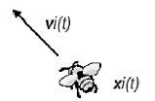

Figure 2.8: Particle with position and velocity vector

Every particle will have its own memory where he will store his best position (pbest) so far and the swarm’s global best position (gbest), when these 2 values are identified the velocity of the particle is updated using this correlation

(2.37)

where is a randomly generated number that is bounded between 0 and 1, and are cognitive and social acceleration constants respectively and they are normally set to 2.

This velocity and position update is shown in Figure 2.7

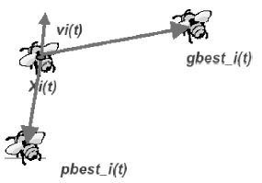

Figure 2.9: Velocity update of particles

The following correlation performs the position update of the swarm particle and it’s shown in Figure 2.8

(2.38)

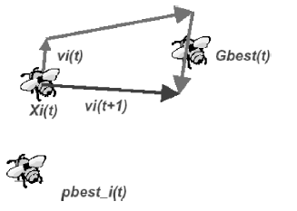

Figure 2.10: Position update of particles

The above process is on loop for every particle in the swarm until the optimal solution is found, then the PSO gets terminated

2.4.2 Applications of Particle Swarm Optimization

PSO has been used in a lot of real-world fields, Sivanandam and Deepa (2008) highlights the most important real-world problems that PSO are applied to solve, problems related to the operation and control of power systems, problems related to job scheduling, problems related to vehicle routing, scheduling of batch processes and much more.

Gaing (2003) used PSO to solve the economic dispatch problem in power systems, his objective was to simultaneously minimize the generation cost rate while meeting the power system’s load demand, the whole system was subjected to constraints like power balance, generator operation and line flow but with the good ability of PSO in handling constraints, the problem was solved. Robinson and Samii (2004) used PSO in the field of electromagnetics, they optimized the length, the number of corrugations per wavelength, ratio of tooth width to total corrugation width, profile parameter and matching section parameter so that when given a specific operating condition, all you have to do is to input the operating conditions and the optimal design will be generated by the PSO algorithm. Another common problem that PSO solves is the optimization of cutting parameters in machining operations. Machining parameters are very important in manufacturing industries as they affect the quality and the finish of the product, just recently, Pinzon, Abolghasem, Maranon and Rodriguez (2020) optimized the cutting parameters of AI-6063 workpiece using PSO, they optimized the angle of the rake, the velocity, and the cutting feed with the objective of minimizing cutting force, maximizing the microstructure refinement and maximizing the rate of material removal. In the sustainable energy field, field Ebrahimi, Abedini and Rezaei (2020) optimized the schedule of distributed generations in microgrids with the objective of minimizing system peak load. And the applications of PSO are limitless, they are only limited to the engineer’s imagination.

These wide variety of real-world applications strengthens the claim that PSO’s are efficient and effective in solving optimization problems, not only that but it’s also claimed that PSO produce the most accurate solutions among all optimization algorithms which is one of the main reasons PSO will be used to optimize the Plate Fin Heat Exchanger.

2.5 Optimizations on Plate Fin Heat Exchangers

Peng and Ling (2008) were able to successfully apply Genetic Algorithm + Back propagation neural networks to minimize the weight of the PFHE for specific operating conditions (heat duty and allowable pressure drop). They also managed to minimize the total annual cost of the PFHE which is equal to Capital cost + Operating cost + Maintenance cost. The objective function that they optimized to minimize the total annual cost was as the following:

(2.39)

(2.40)

Where is a fixed cost ($), A is the heat transfer area of the PFHE ( is the unit cost of PFHE per area (, is the operating period (years) and is the annual coefficient factor and is calculated by

(2.41)

(2.42)

Where E is the pumping power

However, Sanaye and Hajabdollahi (2010) had a different approach to optimize the total annual cost of the plate fin heat exchanger using Genetic Algorithm, the objective function that they used produced more accurate results and was more solid than that used by Peng and Ling (2008), The objective function that they developed is as following:

(2.43)

Where the investment cost is the annual cost of the heat transfer surface are, the operating cost is the cost of operating a compressor to flow the fluid and they can be described by the following equations.

(2.44)

(2.45)

Where is the PFHE investment cost per unit surface area, is the electrical unit cost, is a constant, τ is the operation duration in hours/year, η is the compressor efficiency, is the volumetric flow rate of the fluid and is the total heat transfer area of the PFHE.

As observed from the objective function developed by Sanaye and Hajabdollahi (2010), They incorporated more details in the correlation like the electricity price, the compressor efficiency and the volumetric flow rate of the fluid. Hadid (2015) used the same Objective function developed by Sanaye and Hajabdollahi (2010), to optimize the total cost of the PFHE, and this shows the viability of the objective function and the accuracy of its correlation to optimize the total cost of the PFHE. Hadid used Biogeography based optimization algorithm to minimize the total cost of the PFHE and claimed that Biogeography Based Optimized algorithms provided better solutions than Genetic Algorithms, this claim will be evaluated in this project by comparing the results obtained with the results with provided by Hadid. Wang and Li (2015) also used the Objective function developed by Sanaye and Hajabdollahi (2010) to optimize the total cost of the PFHE using Cuckoo Search Algorithm, He also minimized the number of entropy generation units which is a second objective function that improves the thermodynamic efficiency of the PFHE. The objective function related to the number of entropy generations which was subjected to minimization was developed by Mishra (2009) where he describes the number of entropy generation units by the following correlation.

(2.45)

Where is the rate of entropy generations and is described by the following correlation

(2.46)

Zarea (2013) successfully used the Bees Algorithm to maximize the effectiveness and to minimize the number of entropy generation units of the PFHE. He claims that Bees Algorithm is more accurate than Genetic Algorithms, Particle Swarm Algorithms and ICA Algorithm. This claim will be evaluated in this project to identify what’s the evolutionary algorithm that has the strongest ability of auto searching optimal solutions and optimizing the design of Plate Fin Heat Exchangers. Wen (2016) used Genetic Algorithms to maximize the effectiveness and minimize the total cost of the PFHE simultaneously using a Multi Objective Genetic Algorithm (NSGAII), Raja, Jhala and Patel (2017) used multi objective heat transfer search algorithm to maximize the effectiveness and minimize the total cost of the PFHE simultaneously, Yousefi, Enayatifar, Darus and Abduallah (2012) used harmony search algorithm to minimize the pressure drop, and to minimize the heat transfer area. the correlation of the effectiveness of the PFHE used in these papers is provided by Incropera and DeWitt (1998) and the correlation of the total cost, heat transfer area and pressure drop of the PFHE used in these papers is provided by Sanaye and Hajabdollahi (2010), And this shows us the validity of these correlations in optimizing the cost and the effectiveness of the PFHE. Yousefi (2011) claim that Imperial competitive algorithm (ICA) is a promising algorithm for solving engineering problems especially in thermal system designs, this claim will be evaluated in this project in the form of comparison, the solutions obtained by GWO, GA and PSO will be compared to the solutions obtained from ICA algorithm.

To conclude this literature review, the optimization of PFHE is possible through Evolutionary Algorithms as it was done before by researchers, however there are different claims on the best EA that will find the optimal solution in the least computation time, in this project, optimization of the design of the PFHE with the objective of minimizing the total annual cost will be investigated using the objective function provided by Sanaye and Hajabdollahi (2010). Grey wolf optimization algorithm, Genetic Algorithm and Particle Swarm Algorithm will be used in the optimization process and the solutions obtained will be compared with that obtained by researchers, according to that comparison the best EA to be used in Thermal System applications and in optimizing the PFHE will be identified.

CHAPTER 3: METHODOLOGY

3.1 Objective Definition

The main goal of this project is to optimize the total annual cost of the PFHE using EA’s, evaluate the performance of these EA’s in terms of optimal solution (least total annual cost) computation time (least computation time) and identify the best evolutionary algorithm among the EA’s that was used. In this project Genetic Algorithm and Particle Swarm Optimization Algorithm will be used to minimize the total annual cost of the PFHE, the solutions obtained from these two algorithms will be compared and evaluated among each other and then compared with solutions obtained by researchers that have used different EA’s in optimizing the total annual cost of the PFHE, and according to this comparison the best EA will be determined, which then can be used to optimize thermal systems generally and plate fin heat exchangers specifically.

3.2 Case Study

The preliminary design (Darus et al., 2011). of the Plate Fin Heat Exchanger (PFHE) is shown in Table 3.1 where the Total Annual Cost of the preliminary design is $6780.7

Table 3.1: Preliminary design and total annual cost of the Plate Fin Heat Exchanger

|  |  |
| --- | --- |
| **Preliminary Design** | **Value** |
| Cold flow length, | 0.3 |
| Hot flow length, | 0.3 |
| Fin heigh, | 0.00249 |
| Fin thickness, | 0.000102 |
| Fin frequency, | 782 |
| Fin offset length, | 0.00318 |
| Number of hot side layer, | 167 |
| Total Annual Cost ($ / year) | 6780.7 |

In this project, the design of the preliminary PFHE will be optimized with the objective of minimizing it’s total annual cost. However to ensure that there is no loss of performance, constraints are set. The heat duty of the PFHE has to be equal to or more than 1069.8 W, the hot flow length is from 0.1m to 1m, the cold flow length is from 0.1m to 1m and the no flow length is 1.5m. The PFHE is constructed from aluminum with a density of 2700 . The maximum allowable pressure drop in the hot side and cold side is 9.5 kPa and 8 kPa respectively, the mass flow rate and the temperature of the fluid is considered in the design specifications.

Table 3.2 shows the operating conditions of the PFHE used in this project; these operating conditions are considered as the inputs of this optimization problem. Lower and upper bounds of the design parameters are shown in Table 3.3, Furthermore the economic parameters required for optimizing the total annual cost are listed in Table 3.4.

Table 3.2: Operating conditions of the case study (input)

|  |  |  |
| --- | --- | --- |
| **Parameters** | **Hot side** | **Cold Side** |
| Mass flow rate, | 1.66 | 2 |
| Inlet Temperature, | 900 | 200 |
| Density of exchanger fluid, | 0.6296 | 0.9638 |
| Specific heat, | 1122 | 1073 |
| Viscosity, | 4.01E-05 | 3.36E-05 |
| Prandtl number, | 0.731 | 0.694 |

Table 3.3: Lower and upper bounds of the design parameters (output)

|  |  |  |
| --- | --- | --- |
| **Design Parameters** | **Lower Bound** | **Upper Bound** |
| Cold flow length, | 0.1 | 1 |
| Hot flow length, | 0.1 | 1 |
| Fin height, | 0.002 | 0.01 |
| Fin thickness, | 0.0001 | 0.0002 |
| Fin frequency, | 100 | 1000 |
| Fin offset length, | 0.001 | 0.01 |
| Number of hot side layer, | 1 | 200 |

Table 3.4: Economic parameters of the PFHE

|  |  |
| --- | --- |
| **Economic Parameters** | **Value** |
| Cost per unit area, | 90 |
| Electricity price, | 20 |
| Hours of operation, | 5000 |
| Nonlinear exponent, | 0.6 |
| Depreciation time, | 10 |
| Compressor efficiency, | 0.6 |
| The rate of interest, | 0.1 |

3.3 Objective Function and Constraints

In order to optimize the PFHE using an Evolutionary Algorithm, identification of the objective function (the function that it is desired to maximize or minimize) is required, in this project the main objective is to optimize the total annual cost of the PFHE, therefore, the objective function is a function that describes the total annual cost of the PFHE, the total annual cost (TAC) can be estimated from the following correlation:

(3.1)

Where is the total annual cost, is the capital cost and is the operating cost, is describe in this correlation

(3.2)

Where is the cost per unit surface area, is the total heat transfer area, is the exponent of nonlinear increase with area increase and is the annual coefficient factor and is described by the following correlation

(3.3)

Where is the interest rate and is the depreciation time.

The operating cost is described by the following correlation

(3.4)

Where V is the volumetric flow rate of the fluid, is the electricity price, is the operating hours per year, is the density of the fluid, is the compressor efficiency and is the pressure drop and described in Equations 2.20 and 2.21.

Therefore, the objective function can be described as the following

(3.5)

Where is the vector of the design parameters which are bounded between minimum and maximum values. The design parameters in the optimization problem are cold side flow length (), hot side flow length (), fin height (), fin thickness (), fin frequency (), fin offset length () and the number of plate layers (). is the penalty number and are the constraints. Constraints are important to ensure that minimizing the total annual cost would not results in decreasing the performance of the PFHE. Therefore, the constraints related to the objective function ensures that minimizing the total annual costs satisfies the maximum allowable pressure drop, maximum allowable weight and the flow characteristics of the exchanger fluid.

The constraints are described by the following correlations

(3.6)

(3.7)

(3.8)

(3.9)

(3.10)

(3.11)

(3.12)

These 7 constraints will be inputted in the objective function to ensure that they are all satisfied when minimizing the total annual cost.

3.4 Optimization Methods

Evolutionary Algorithms have been and are being used in optimizing Engineering related problems, GA and PSO are among the most used EA’s, and GWO has never been applied on PFHE, therefore in this project these 3 algorithms will be implemented

3.4.1 Grey Wolf Optimizer Implementation

The steps for implementing the Grey Wolf Optimization Algorithm to our optimization problem is as described in Figure 3.1 where the steps for every block is as following:

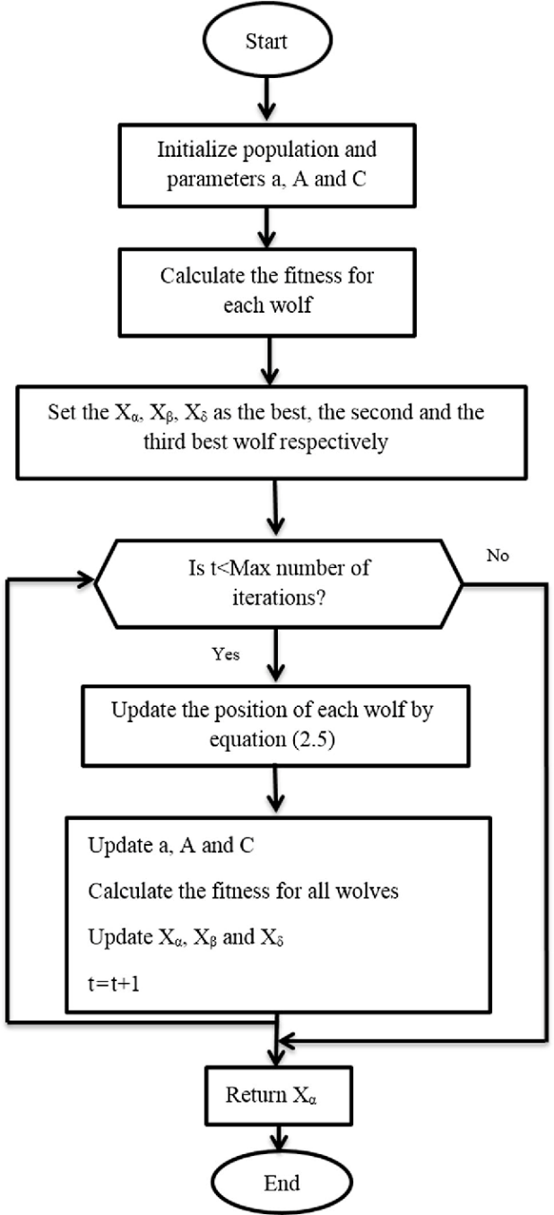

*Step 1*: is to Input all the important parameters related to the properties of the Grey Wolf Optimization (GWO) algorithm (a, A and C) and the design problem, these parameters include, Population size, Number of iterations at which algorithm is terminated, the amount of design parameters (7), the upper and lower bounds of these design parameters as shown in Table 3.3 and the constraints that the PFHE is subject to.

*Step 2*: is to create a random population that is equal to the population size defined in step 1. Every candidate in the population with carry a random value for all of the design parameters.

*Step 3*: is to find the objective function value of all of the wolves, thus every wolf will carry his own objective function value that has met all constraint requirements, this value is considered “The fitness value”, Since the problem is a minimization problem thus the fittest wolves are the candidates that carry the lowest fitness value.

*Step 4*: Update the positions (vectors) of the best three wolves, , and. Where will carry the design parameters of the best solution obtained, will carry the design parameters of the second best solution obtained and will carry the design parameters of the third best solution.

*Step 5*: Check if the maximum iteration number is reached or not, if it is reached, the algorithm will be terminated and the best solution will be displayed if not, a, A and C values will be updated.

*Step 6*: Calculate the new fitness value for all wolves.

*Step 7*: Update the positions of the best three wolves , and with the new best positions obtained and increase the iteration number by 1

*Step 8*: Repeat steps 5 till 7 until the maximum iteration number is reached.

Figure 3.1: GWO Flow Chart

3.4.2 Genetic Algorithm Optimization Implementation

The steps for implementing the Genetic Algorithm to our optimization problem is as described in Figure 3.2 where the steps for every block is as following:

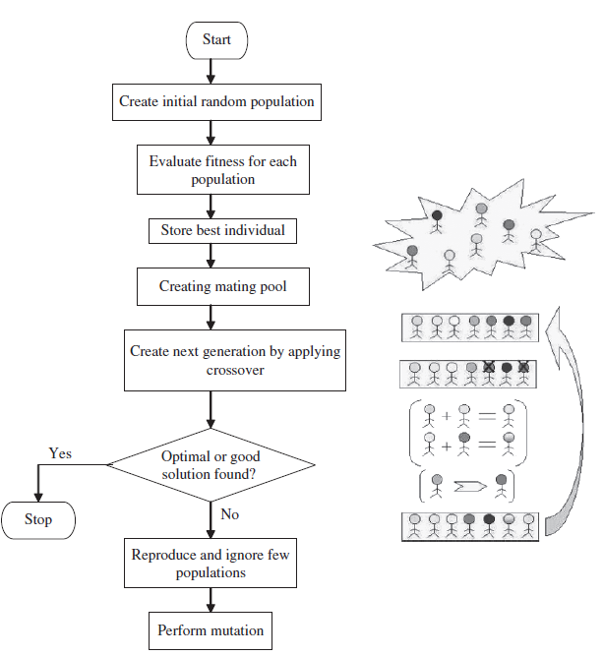*Step 1:* is to Input all the important parameters related to the properties of the Genetic Algorithm (GA) and the design problem, these parameters include, Population size, Number of iterations to terminate the algorithm, mutation probability, cross over probability, the amount of design parameters (7), the upper and lower bounds of these design parameters as shown in Table 3.3 and the constraints that the PFHE is subject to.

*Step 2:* is to create a random population that is equal to the population size defined in step 1. Every candidate in the population with carry a random value for all of the design parameters.

*Step 3:* is to find the objective function value of all of the population candidates, thus every candidate will carry his own objective function value that has met all constraint requirements, this value is considered “The fitness value”, Since the problem is a minimization problem thus the fittest candidates are the candidates that carry the lowest fitness value.

*Step 4:* is the selection procedure step, In this step a pool of the fittest candidates is created and the unfit candidates are eliminated, this is done through the roulette wheel selection mechanism, where the probability of the candidate to be qualified is determined by his fitness value, if his fitness value is close to the fittest candidate he will have more entries in the roulette wheel, therefore the chances of him being qualified become high, this step resembles the concept “survival of the fittest”

*Step 5:* is the crossover step where 2 candidates are chosen randomly from the pool of the fittest candidates to output 2 off-springs. That have features similar to their parents. Thus, more fit candidates are created replacing those who got eliminated.

Figure 3.2: GA Flow chart

*Step 6:* is the mutation step, the number of candidates that undergo mutation are determined by the mutation probability value, in normal cases it’s kept low because high probability values make the algorithm unstable

*Step 7:* Candidates that contain the best solutions so far “the fittest” are saved and they are not chosen for mutation and crossover until new candidates with better solution are found.

*Step 8:* The steps from step 3 until step 7 are set on loop until the algorithm termination criteria is met (specific computation time or number of iterations).

3.4.3 Particle Swarm Optimization Implementation

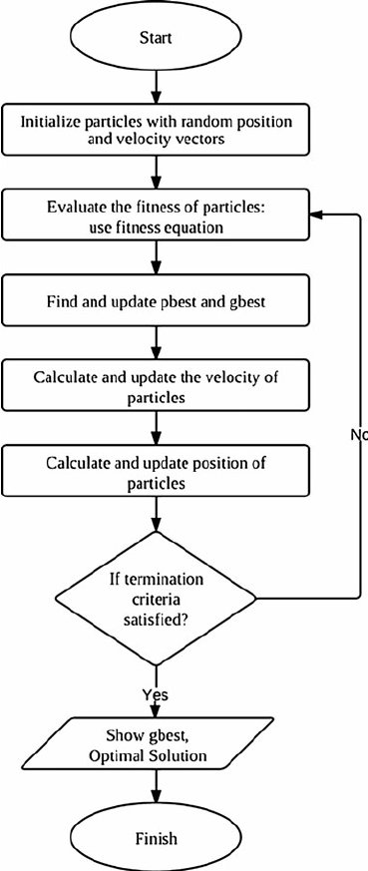The steps for implementing the Particle Swarm Optimization algorithm to our optimization problem is as described in Figure 3.3 where the steps for every block is as following:

*Step 1:* is to Input all the important parameters related to the properties of the Particle Swarm Optimization (PSO) and the design problem, These parameters include, Population size, Number of iterations after which the algorithm is terminated, maximum velocity of particles, constant value of social acceleration, constant value of cognitive acceleration, the range of inertia weight, the amount of design parameters (7), the upper and lower bounds of these design parameters as shown in Table 3.3 and the constraints that the PFHE is subject to.

*Step 2:* is to create a random population that is equal to the population size defined in step 1. Every candidate in the population with carry a random value for all of the design parameters. The population resembles the swarm particles.

*Step 3:* is to find the objective function value of all of the population (particles), thus every particle will carry its own objective function value that has met all constraint requirements, this value is considered “The fitness value” and for every particle it’s saved as pbest (personal best), Since the problem is a minimization problem thus the fittest particle is the particle that carries the lowest fitness value, and this value is saved as gbest (global best)

*Step 4:* In this step the velocities of all particles are updated by using Equation 2.24, After the update the velocity of the particle is checked to make sure it does not exceed the maximum velocity, in case it exceeds the maximum velocity, it drops down to the maximum velocity value

*Step 5:* In this step the positions of all particles are updated using Equation 2.25, When the positions are updated, they must satisfy the constraint conditions and the design parameters upper and lower bounds.

*Step 6:* In this step objective function value for all particles in the swarm is acquired, In the case that the new solution for a particle is better than its current pbest, it replaces it and becomes the new pbest, and If there is a new fittest solution (the most minimum value since the problem is subjected to minimization) that has a better value that the current gbest, it’s replaces the gbest and becomes the new global best (gbest)

*Step 7:* Particles that contain the best solutions so far “the fittest” are saved and they do not become subjected to update unless better particles (solutions) appear.

Figure 3.3: PSO Flow Chart

*Step 8:* The steps from step 4 until step 7 are set on loop until the algorithm termination criteria is met (specific computation time or number of iterations).

3.5 Optimization of GWO, GA and PSO algorithms.

Solutions obtained by an algorithm can vary depending on the algorithm properties (Population size and Maximum iteration number) therefore, for the algorithms to obtain the “Best solutions possible” their properties need to be optimized.

Solutions obtained by optimization algorithms are highly dependent on the Population size, some algorithms perform well and obtain better solutions when the population size is low, and others perform well and obtain better solutions when the population size is high, therefore it is crucial to identify the optimal population size for every algorithm. the optimal population size can be obtained by running the algorithm for 10 times on different population sizes, and the results obtained by different population sizes will be compared among each other where the population size at which the algorithm obtained the best solution will be considered the optimal population size for the algorithm.

Computation time is directly proportional to the maximum iteration number, therefore, to avoid excessive computation time and unnecessary iterations the optimal iteration number can be defined as the point as the point at which the convergence line in a convergence graph reaches a steady state and stops converging.

CHAPTER 4: RESULTS AND DISCUSSION

4.1 Grey Wolf Optimization algorithm Best Solution, Properties and Performance

GWO algorithm was tested using different population sizes starting from a population size of “10” moving all the way up to a population size of “100” with a step size of 10. During every test, the algorithm ran for 10 times to obtain 10 different solutions, this is important to be able to measure the stability of the algorithm by calculating the standard deviation. The GWO algorithm computed its best solution at a population size of 40 as shown in Table 4.1, the best solution obtained is 919.6868 $/year as shown in Figure 4.1

|  |  |  |  |  |  |  |  |  |  |  |  |  |  |  |
| --- | --- | --- | --- | --- | --- | --- | --- | --- | --- | --- | --- | --- | --- | --- |
| **TAC** | | |  |  | |  |  |  | |  |  | | | |
| 923.9433 | | | 0.73551 | 0.972637 | | 0.009998 | 0.000196 | 238.7829 | | 0.008483 | 73.07992 | | | |
| 924.6908 | | | 0.756369 | 0.961408 | | 0.01 | 0.000182 | 241.3236 | | 0.009438 | 73.17185 | | | |
| 923.7008 | | | 0.757201 | 0.998404 | | 0.01 | 0.0002 | 231.94 | | 0.008801 | 72.98237 | | | |
| 920.2634 | | | 0.804759 | 1 | | 0.01 | 0.000195 | 211.6428 | | 0.006077 | 73.09565 | | | |
| 919.6868 | | | 0.803492 | 1 | | 0.01 | 0.000195 | 204.8749 | | 0.004914 | 73.07694 | | | |
| 923.0636 | | | 0.782745 | 0.998331 | | 0.01 | 0.000189 | 225.6353 | | 0.008122 | 73.08565 | | | |
| 924.4711 | | | 0.752612 | 0.993772 | | 0.009984 | 0.000195 | 235.8709 | | 0.009398 | 73.20713 | | | |
| 921.3626 | | | 0.771023 | 0.97575 | | 0.01 | 0.000189 | 224.1754 | | 0.006654 | 73.12857 | | | |
| 922.5267 | | | 0.775703 | 0.980198 | | 0.009998 | 0.000178 | 227.391 | | 0.007384 | 73.10508 | | | |
| 925.4105 | | | 0.722319 | 0.932043 | | 0.009994 | 0.000182 | 251.3099 | | 0.009102 | 73.22994 | | | |
|  |  |  | | | Standard Deviation = 1.93 | | | |  | | |  |  |  |

**Table 4.1:** 10 GWO Solutions at population size of 40

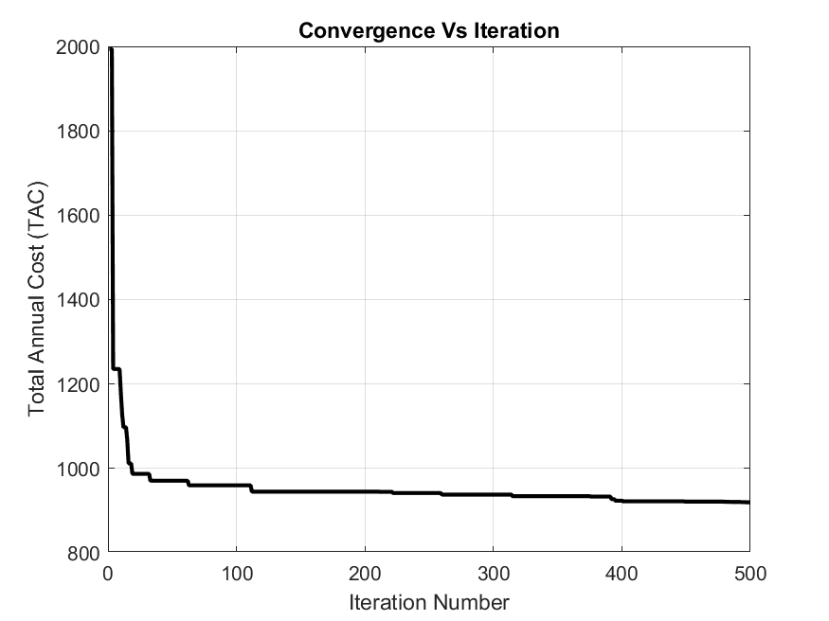

Figure 4.1: GWO Best solution convergence graph

4.2 Genetic Algorithm Best Solution, Properties and Performance

GA algorithm was tested using different population sizes starting from a population size of “10” moving all the way up to a population size of “310” with a step size of 10. During every test, the algorithm ran for 10 times to obtain 10 different solutions, The GA algorithm computed its best solution at a population size of 260 as shown in Table 4.2, the best solution obtained by the Genetic Algorithm is 945.9534 $/year as shown in Figure 4.2

|  |  |  |  |  |  |  |  |  |  |  |  |  |  |  |
| --- | --- | --- | --- | --- | --- | --- | --- | --- | --- | --- | --- | --- | --- | --- |
| **TAC** | | |  |  | |  |  |  | |  |  | | | |
| 1049.06 | | | 1 | 1 | | 0.01 | 0.000158 | 248.8107 | | 0.01 | 54.5088 | | | |
| 1027.555 | | | 1 | 1 | | 0.01 | 0.000163 | 241.4583 | | 0.01 | 54.01351 | | | |
| 1066.685 | | | 1 | 1 | | 0.01 | 0.000155 | 254.8412 | | 0.01 | 54.91581 | | | |
| 1074.12 | | | 1 | 1 | | 0.01 | 0.000153 | 257.3866 | | 0.01 | 55.0877 | | | |
| 947.9766 | | | 1 | 1 | | 0.01 | 0.000191 | 206.5546 | | 0.01 | 67.15805 | | | |
| 1012.052 | | | 1 | 1 | | 0.01 | 0.000167 | 236.1611 | | 0.01 | 53.658 | | | |
| 945.9534 | | | 1 | 1 | | 0.009993 | 0.000193 | 204.1178 | | 0.01 | 68.98867 | | | |
| 1042.595 | | | 1 | 1 | | 0.01 | 0.00016 | 246.5997 | | 0.01 | 54.35973 | | | |
| 999.3598 | | | 1 | 1 | | 0.01 | 0.00017 | 231.8263 | | 0.01 | 53.36831 | | | |
| 998.365 | | | 1 | 1 | | 0.01 | 0.00017 | 231.4866 | | 0.01 | 53.34571 | | | |
|  |  |  | | | Standard Deviation = 44.742 | | | |  | | |  |  |  |

**Table 4.2:** 10 GA Solutions at population size of 260

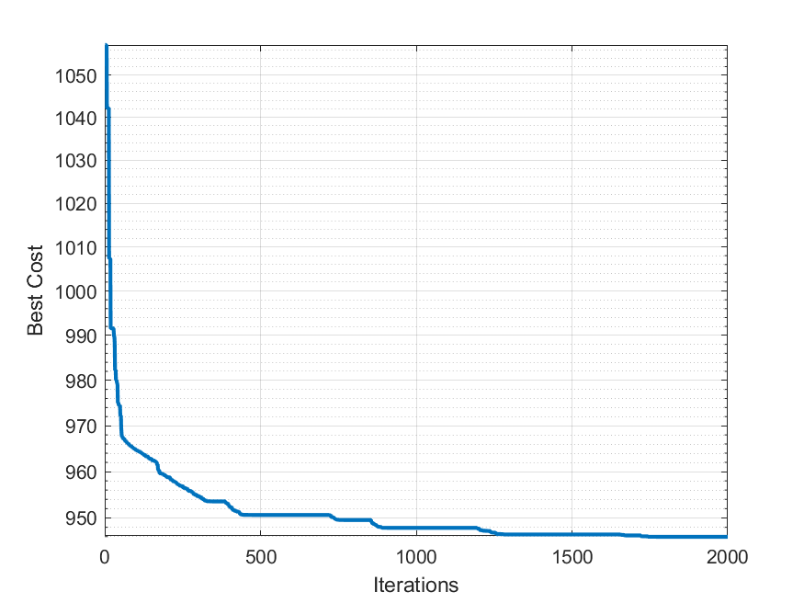

Figure 4.2: GA Best solution convergence graph

4.3 Particle Swarm Optimization algorithm Best Solution, Properties and Performance

PSO algorithm was tested using different population sizes starting from a population size of “10” moving all the way up to a population size of “200” with a step size of 10. During every test, the algorithm ran for 10 times to obtain 10 different solutions, The PSO algorithm computed its best solution at a population size of 150 as shown in Table 4.3, the best solution obtained by the PSO algorithm is 919.4412 $/year as shown in Figure 4.3

|  |  |  |  |  |  |  |  |  |  |  |  |  |  |  |
| --- | --- | --- | --- | --- | --- | --- | --- | --- | --- | --- | --- | --- | --- | --- |
| **TAC** | | |  |  | |  |  |  | |  |  | | | |
| 926.3136 | | | 0.712955 | 0.906435 | | 0.009999 | 0.000155 | 254.1044 | | 0.007584 | 73.38261 | | | |
| 931.3964 | | | 0.709565 | 0.900655 | | 0.00937 | 0.000153 | 258.3591 | | 0.008587 | 78.27794 | | | |
| 919.4412 | | | 0.8094 | 1 | | 0.009999 | 0.000191 | 206.7299 | | 0.005294 | 73.09711 | | | |
| 923.5367 | | | 0.74308 | 0.937818 | | 0.01 | 0.000164 | 240.0878 | | 0.007201 | 73.3115 | | | |
| 925.7124 | | | 0.730939 | 0.916627 | | 0.009999 | 0.000158 | 252.1319 | | 0.008452 | 73.36586 | | | |
| 925.8827 | | | 0.73329 | 0.934492 | | 0.01 | 0.000161 | 252.0292 | | 0.009379 | 73.33249 | | | |
| 925.0483 | | | 0.732934 | 0.955732 | | 0.009814 | 0.000168 | 240.5759 | | 0.007682 | 74.65727 | | | |
| 920.5033 | | | 0.776581 | 0.977112 | | 0.009999 | 0.000189 | 215.9411 | | 0.005376 | 73.1363 | | | |
| 924.9139 | | | 0.721083 | 0.932875 | | 0.01 | 0.000159 | 247.5974 | | 0.007567 | 73.34856 | | | |
| 925.3109 | | | 0.729543 | 0.931352 | | 0.009987 | 0.000158 | 249.0672 | | 0.008219 | 73.43259 | | | |
|  |  |  | | | Standard Deviation = 3.282 | | | |  | | |  |  |  |

**Table 4.3:** 10 PSO Solutions at population size of 150

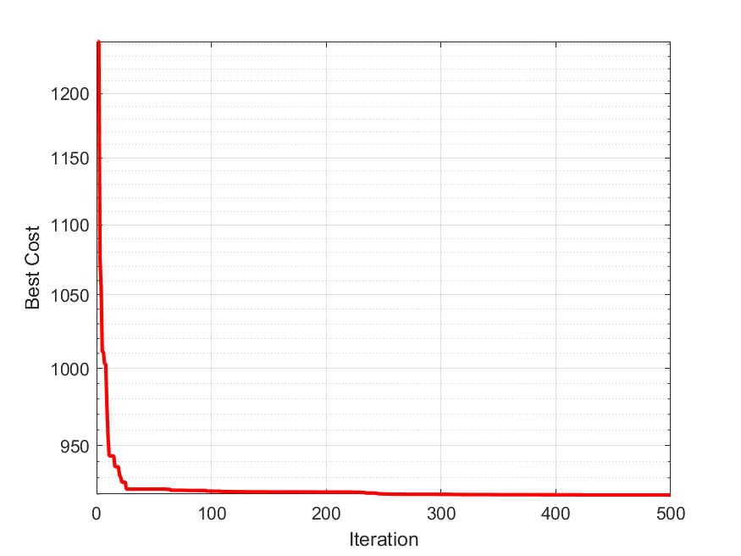

Figure 4.3: PSO Best solution convergence graph

4.4 Discussion and Analysis

|  |  |  |  |  |  |  |
| --- | --- | --- | --- | --- | --- | --- |
|  |  | **Preliminary Design** | **GWO** | **GA** | **PSO** | **Yousefi (2012) ICA** |
|  |  |  |  |  |  |  |
|  |  | 0.3 | 0.8035 | 1 | 0.8094 | 0.83 |
|  |  | 0.3 | 1 | 1 | 1 | 1 |
| **Design** |  | 0.00249 | 0.01 | 0.009993 | 0.009999 | 0.0097 |
| **parameter** |  | 0.000102 | 0.000195 | 0.000193 | 0.000191 | 0.0002 |
|  |  | 782 | 204.875 | 204.1178 | 206.73 | 228.2 |
|  |  | 0.00318 | 0.00491 | 0.01 | 0.0053 | 0.01 |
|  |  | 167 | 73.1 | 68.99 | 73.1 | 73 |
|  |  |  |  |  |  |  |
| **Objective** | TAC | 6780.7 | 919.687 | 945.953 | 919.441 | 942 |
| **function** |  |  |  |  |  |  |
|  |  |  |  |  |  |  |
|  |  | 0.4928 | 0.4783 | 0.4802 | 0.4737 | 0.4402 |
|  |  | 0.0321 | 0.0381 | 0.0193 | 0.0361 | 0.0200 |
|  |  | 0.0867 | 0.0411 | 0.0410 | 0.0411 | 0.0478 |
| **Constraints** |  | 577.35 | 369.41 | 398.85 | 367.90 | 357.19 |
|  |  | 825.22 | 652.14 | 565.32 | 644.76 | 610.44 |
|  |  | 9.34 | 0.28 | 0.30 | 0.28 | 0.28 |
|  |  | 6.90 | 0.34 | 0.21 | 0.33 | 0.30 |
|  | Q | 1071 | 1069.8 | 1068.9 | 1069.8 | 1071.1 |
|  |  |  |  |  |  |  |
|  | Standard Deviation |  | 1.93 | 44.742 | 3.282 |  |
|  | Computation Time (s) |  | 24.3 | 2.6 | 1.2 |  |
|  |  |  |  |  |  |  |

Table 4.4: Comparison between GWO, GA, PSO and ICA algorithms

Table 4.4 presents a side by side comparison of the standard deviation, computation time at (Population size: 70, Maximum iteration: 200) and the best solutions obtained by the Grey wolf optimization (GWO) algorithm, Genetic algorithm (GA), Particle Swarm Optimization (PSO) algorithm and the Imperialist competitive algorithm by Yousefi (2012).

The Total Annual Cost (TAC) of the Preliminary heat exchanger got reduced by Approximately 86 % after the implementation of the optimization algorithms, no constraints (equations 3.6 – 3.12) were violated as shown in Table 4.4 thus ensuring that the optimized design parameters will result in the required thermal performance as per the preliminary heat exchanger.

However some optimization algorithms perform better than others, As shown in Table 4.4, Through equations (2.37 – 2.38), PSO algorithm computed the best solution among all algorithms (919.441 $/year), Through equations (2.23 – 2.35), GWO algorithm computed the 2nd best solution (919.687 $/year) which is very close to the solution obtained by PSO algorithm, (Yousefi 2012) ICA algorithm holds the 3rd place (942 $/year) and through equation 2.36, GA algorithm’s best solution holds the final place (945.953 $/year).

To furtherly investigate the performance of the algorithms, the stability of the algorithm is measured by calculating the standard deviation, as shown in Table 4.4 the GWO algorithm is the most stable having the lowest standard deviation value, following it is PSO and GA respectively.

Optimization of Plate Fin Heat exchangers was never investigated and solved using GWO algorithm, the solution obtained by the GWO algorithm in this project proves the efficiency and effectiveness of it as it out performs 2 of the most well-known and widely used algorithms, GA and ICA. However one downside of the GWO algorithm was noticed when a comparison between the computation time of all 3 algorithms was conducted were the GWO, GA and PSO algorithms were tested under the same algorithm properties (Population size: 70, Maximum iteration: 200) and it was found that it took 24.3527 seconds for the GWO algorithm to compute the best solution compared to PSO algorithm at 1.27 seconds and GA algorithm at 2.6 seconds, the high computation time can be explained by the complexity of the mathematical model of the GWO algorithm as there are 13 equations (2.23 – 2.35) involved in the computation process compared the PSO algorithm having 2 equations only (2.37 – 2.38) and 1 equation for the GA algorithm (2.36).

CHAPTER 5: CONCLUSION

Plate Fin Heat Exchangers are thermally effective and efficient heat exchangers due to their high compactness and small size, used in applications like ammonia production, nuclear engineering and natural gas liquification. However, a disadvantage associated with them is their high investment cost. The main objective of this project was to optimize the PFHE’s design parameters with the objective of minimizing its total annual cost (TAC).

Investigation of the PFHE thermal model was conducted to study the thermodynamic and economic correlations associated with the design parameters of the PFHE.

The design parameters of the PFHE were optimized in this project using GWO, GA and PSO algorithms without the violation of any constraints. The optimization of the design parameters of the PFHE was never investigated and solved using GWO algorithm. The GWO was found to be the most stable algorithm with the minimum standard deviation value, however GA high standard deviation shows its instability in optimizing the PFHE compared to GWO and PSO.

GWO and PSO algorithms outperformed the GA algorithm and the ICA algorithm by obtaining a far superior solutions and optimized design parameters but the main disadvantage of the GWO is its high computation time, however further investigation of the integration of the PSO algorithm within the GWO algorithm can result in a stable, fast and good performing hybrid algorithm.

APPENDIX I: RESEARCH WORK SCHEDULE

|  |  |  |  |  |  |  |  |  |  |  |  |  |  |  |  |  |  |
| --- | --- | --- | --- | --- | --- | --- | --- | --- | --- | --- | --- | --- | --- | --- | --- | --- | --- |
| **ID** | **TASK** | **Week 1** | **Week 2** | **Week 3** | **Week 4** | **Week 5** | **Week 6** | | **Week 7** | **Week 8** | | **Week 9** | **Week 10** | **Week 11** | **Week 12** | **Week 13** | **Week 14** |
|  |  |  |  |  |  |  |  | **SEMESTER 1** | | |  |  |  |  |  |  |  |
| 1 | Research on Evolutionary Algorithm |  |  |  |  |  |  | |  |  | |  |  |  |  |  |  |
| 2 | Research on Thermal Systems |  |  |  |  |  |  | |  |  | |  |  |  |  |  |  |
| 3 | System Analysis and Validation |  |  |  |  |  |  | |  |  | |  |  |  |  |  |  |
| 4 | Literature Review |  |  |  |  |  |  | |  |  | |  |  |  |  |  |  |
| 5 | MATLAB Code Development (GA) |  |  |  |  |  |  | |  |  | |  |  |  |  |  |  |
| 6 | Obtaining Preliminary Results |  |  |  |  |  |  | |  |  | |  |  |  |  |  |  |
| 7 | Report writing |  |  |  |  |  |  | |  |  | |  |  |  |  |  |  |
| 8 | Report Submission |  |  |  |  |  |  | |  |  | |  |  |  |  |  |  |
| 9 | Presentation |  |  |  |  |  |  | |  |  | |  |  |  |  |  |  |
|  |  |  |  |  |  |  |  | **SEMESTER 2** | | |  |  |  |  |  |  |  |
| 1 | Code Development (PSO) |  |  |  |  |  |  | |  |  | |  |  |  |  |  |  |
| 2 | Code Development (GWO) |  |  |  |  |  |  | |  |  | |  |  |  |  |  |  |
| 3 | Code optimization |  |  |  |  |  |  | |  |  | |  |  |  |  |  |  |
| 4 | Obtaining Results |  |  |  |  |  |  | |  |  | |  |  |  |  |  |  |
| 5 | System modification |  |  |  |  |  |  | |  |  | |  |  |  |  |  |  |
| 6 | Results Evaluation and Comparison |  |  |  |  |  |  | |  |  | |  |  |  |  |  |  |
| 7 | Report Writing |  |  |  |  |  |  | |  |  | |  |  |  |  |  |  |
| 8 | Report Submission |  |  |  |  |  |  | |  |  | |  |  |  |  |  |  |

**Chart 5.1: Research work schedule Gantt Chart**

The Genetic Algorithm developed previous semester needed to be optimized to obtain better results, these modifications where completed this semester, the development, optimization and implementation of grey wolf optimization and particle swarm optimization was completed this semester. The thermal model proposed in the 1st semester had missing constraints where the heat duty was not considered, however this semester the heat duty constraint was added to the thermal model of the PFHE and to the MATLAB codes to ensure that the design parameters of the PFHE will be optimized while satisfying a prescribed heat duty requirement.

REFERENCES

Altan, A., Karasu, S., &amp; Zio, E. (2021). A new hybrid model for wind speed forecasting combining long short-term memory neural network, decomposition methods and grey wolf optimizer. *Applied Soft Computing, 100*, 106996. doi:10.1016/j.asoc.2020.106996

Babaelahi M, Sadri S and Sayyaadi H. (2014) ‘Multi-objective optimization of a cross-flow plate heat exchanger using entropy generation minimization’, *Chemical Engineering Technology*, vol. 37, 87–94.

Cho DH, Seo SK, Lee CJ and Lim Y. (2017) ‘Optimization of Layer Patterning on a Plate Fin Heat Exchanger Considering Abnormal Operating Conditions’, *Applied Thermal Engineering.*

Darrell Whitley, “An Overview of Evolutionary Algorithms: Practical Issues and Common Pitfalls”, Elsevier, *Information and Software Technology*, Vol. 43, Issue. 14, pp. 817-831, Nov. 2001.

Ebrahimi, J., Abedini, M., & Rezaei, M. M. (2020). Optimal scheduling of distributed generations in microgrids for reducing system peak load based on load shifting. *Sustainable Energy, Grids and Networks,* *23*, 100368. doi:10.1016/j.segan.2020.100368

Gaing, Z. (2003). Particle swarm optimization to solving the economic dispatch considering the generator constraints. *IEEE Transactions on Power Systems,* *18*(3), 1187 1195. doi:10.1109/tpwrs.2003.814889

Gupta, E., &amp; Saxena, A. (2016). Performance evaluation of antlion optimizer based regulator in automatic generation control of interconnected power system. *Journal of Engineering, 2016*, 1-14. doi:10.1155/2016/4570617

H. Zarea, F.M. Kashkooli , A.M. Mehryan, M.R. Saffarian, E.N. Beherghani, Optimal design of plate-fin heat exchangers by a Bees Algorithm, *Applied Thermal Engineering* (2013)

Hadidi A. (2015) ‘A robust approach for optimal design of plate fin heat exchangers using biogeography-based optimization (BBO) algorithm’, *Applied Energy*, vol. 150, 196–210.

Hesselgreaves, J. E. (2001). *Compact heat exchangers selection, design, and operation*. New York: Pergamon.

Incropera FP and DeWitt DP. (1998) *Fundamentals of Heat and Mass Transfer*, John Wiley, New York, USA.

J. Kennedy and R. Eberhart, "Particle swarm optimization," *Proceedings of ICNN'95 International Conference on Neural Networks*, Perth, WA, Australia, 1995, pp. 1942-1948 vol.4, doi: 10.1109/ICNN.1995.488968.

Kohli, M., & Arora, S. (2017). Chaotic grey wolf optimization algorithm for constrained optimization problems. Journal ofComputational Design and Engineering.

Li Q, Flamant G, Yuan X, Neveu P and Luo L. (2011) Compact heat exchangers: a review and future applications for a new generation of high temperature solar receivers’, *Renewable and Sustainable Energy Reviews*, vol. 15, 4855–4875.

Liu C, Bu W and Xu D. (2017) ‘Multi-objective shape optimization of a plate-fin heat exchanger using CFD and multi-objective genetic algorithm’, *International Journal of Heat and Mass* *Transfer*, vol. 111, 65–82.

Manglik RM and Bergles AE. (1995) ‘Heat transfer and pressure drop correlations for the rectangular offset strip fin compact heat exchanger’, *Experimental Thermal and Fluid Science*, vol. 10 (2), 171–180

Osorio-Pinzon, J. C., Abolghasem, S., Marañon, A., & Casas-Rodriguez, J. P. (2020). Cutting parameter optimization of Al-6063-O using numerical simulations and particle swarm optimization. *The International Journal of Advanced Manufacturing Technology,* *111*(9-10), 2507-2532. doi:10.1007/s00170-020-06200-1

Patel, V.K., and Savsani, V.J. (2014) ‘Optimization of a plate-fin heat exchanger design through an improved multi-objective teaching-learning based optimization (MO-ITLBO) algorithm’, *Chemical Engineering Research and Design*, vol. 92, 2371–2382.

Peng H, Ling X. (2008) ‘Optimal design approach for the plate-fin heat exchangers using neural networks cooperated with genetic algorithms’, *Applied Thermal Engineering*, vol. 28, 642–650.

Rao, R. V., and Savsani, V. J. (2012). *Mechanical design optimization using advanced optimization techniques*. London: Springer.

Raja BD, Jhala RL and Patel V. (2017a) ‘Many-objective optimization of cross-flow plate fin heat exchanger’, *International Journal of Thermal Sciences*, vol. 118, 320–39.

Raja BD, Patel VK and Jhala RL. (2017b) ‘Thermal design and optimization of fin-and tube heat exchanger using heat transfer search algorithm’, *Thermal Science and Engineering Progress*, vol. 4, 45–57.

Rao RV and Patel VK. (2010) ‘Thermodynamic optimization of cross-flow plate-fin heat exchangers using a particle swarm optimization technique’, *International Journal of Thermal* *Science*, vol. 49, 1712–1721.

Rao RV and Patel VK. (2013) ‘Multi-objective optimization of heat exchangers using a modified teaching-learning-based optimization algorithm’, *Applied Mathematical Modelling*, vol. 37, 1147–1162.

Robinson, J., & Rahmat-Samii, Y. (2004). Particle Swarm Optimization in Electromagnetics. *IEEE Transactions on Antennas and Propagation,* *52*(2), 397-407. doi:10.1109/tap.2004.823969

Sanaye S and Hajabdollahi H. (2010) ‘Thermal-economic multi-objective optimization of plate fin heat exchanger using genetic algorithm’, *Applied Energy*, vol. 87, 1893–1902.

Shah RK, and Sekulic P. (2003) *Fundamental of Heat Exchanger Design*, John Wiley & Sons, New York

Tarek, S., Ebied, H. M., Hassanien, A. E., &amp; Tolba, M. F. (2021). White Blood Cells Segmentation and Classification Using Swarm Optimization Algorithms and Multilayer Perceptron. *International* *Journal of Sociotechnology and Knowledge Development, 13(2),* 16-30. doi:10.4018/ijskd.2021040102

Wang Z and Li Y. (2015) ‘Irreversibility analysis for optimization design of plate fin heat exchangers using a multi-objective cuckoo search algorithm’, *Energy Conversation and* *Management*, vol. 101, 126–135.

Wen J, Ynag H, Tong X, Li K, Wang S and Li Y. (2016) ‘Configuration parameters design and optimization for plate fin heat exchangers with serrated fin by multi-objective genetic algorithm’, *Energy Conversation and Management*, vol. 117, 482–489.

Michalewicz Z, Hinterdingy R, Michalewiczz M, “Evolutionary Algorithms”, *Fuzzy Evolutionary Computation*, pp 3-31,1997,

Mirjalili, S., Mirjalili, S. M.,&Lewis, A. (2014).Greywolfoptimizer. Advances in Engineering Software, 69, 46–61

Zohuri, B. (2017*). Compact heat exchangers: Selection, application, design and evaluation.* Cham, Bavaria: Springer.